01b - Project Kickoff - Completion of NDA and Team IP forms

Group number: 12
NDA | - Completed  - Not needed  Please provide a screenshot as proof, showing whether the task was either not required or was completed and subsequently confirmed by the client (e.g., an email screenshot).  —-------------------------------------------  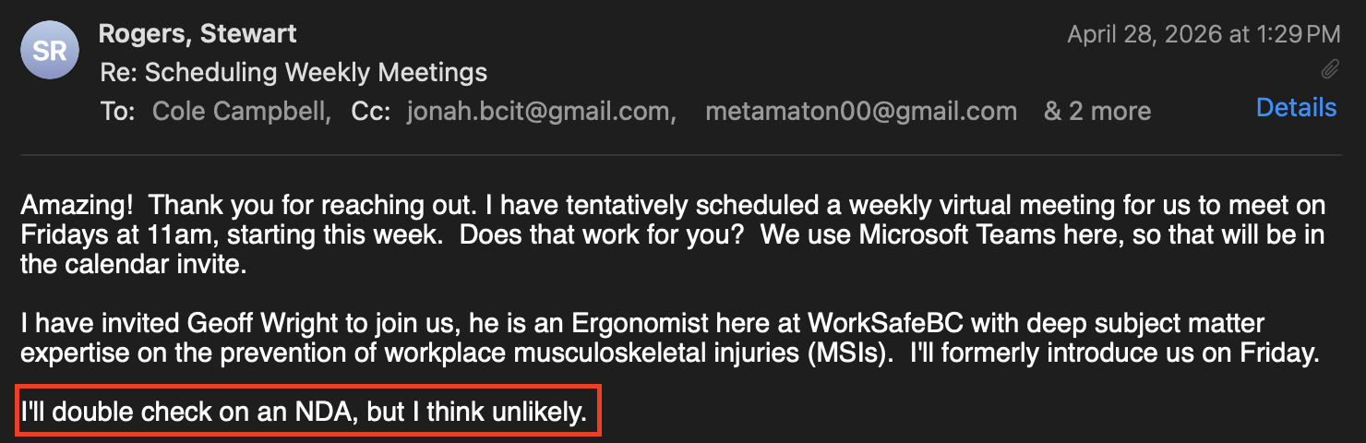  We have not received any other info on an NDA, so we are assuming there is none.

